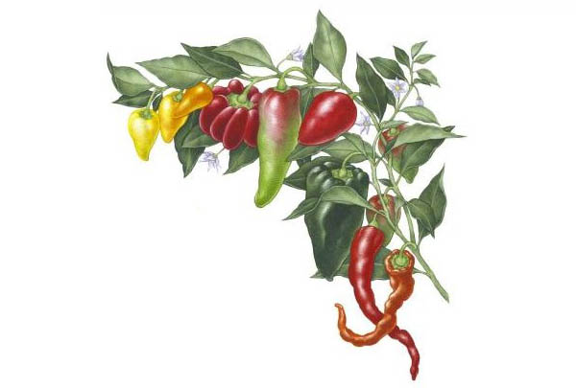
2017 Planting Schedule
Start seed Plant seedling Direct plant Begin
Indoors Out Seed Harvest
VERY EARLY SPRING
Broccoli 1/5 2/22 4/13
Cabbage 1/5 2/22 3/30
Green Peas 2/23 5/4
Spinach 2/23 3/30
Cauliflower 1/19 3/2 4/28
Lettuce 2/2 3/2 3/2 3/30- 4/20
Onion (sets) 1/9 3/2 5/23

EARLY SPRING
Beets 3/9 5/4
Carrots 3/9 5/19
Radishes 3/9 4/7
Sw.Chard 2/2 3/10 3/10 4/10-5/5

SPRING
Beans 3/30 6/3
Corn 3/30 5/12
S.Squash 3/16 3/30 3/30 6/16
Tomatoes 2/16 3/30 6/16

LATE SPRING
Cucumbers 3/23 4/7 4/7 5/26 - 6/10
Eggplant 2/2 4/14 6/23
Melon 2/2 4/14 7/3
Melon 4/13 6/23
Peppers 2/2 4/14 6/23
W. Squash 4/13 7/7

FALL
Carrots 8/25 11/3
Peas 9/1 11/10
Broccoli 7/21 9/8 11/10
Cabbage 7/21 ` 9/8 11/10
Cauliflower 8/4 9/15 11/10
Lettuce 9/22 10/13 11/10
Beets 9/15 11/10
Spinach 9/22 11/10
Radishes 10/13 11/10
Kale 9/22 11/10

